PGP Demo

Scenario
This demo illustrates exchange of files containing sensitive data between the SFG owner organisation and a 3rd party. All sensitive data must be encrypted before sending to the 3rd party and the 3rd party will encrypt before sending to SFG.

Partner1 represents the external partner.
Partner2 represents an internal system that is producing outbound data and consuming inbound data exchanged with partner.
The Partner2 system handles all data unencrypted to SFG will be used to carry out the encryption and decryption.
To demo outbound flow an unencrypted file is uploaded to Partner2’s Inbox. SFG encrypts the file and then delivers it to Partner1’s Encrypted mailbox.
To demo inbound flows an encrypted file is uploaded to Partner1’s Inbox. SFG will decrypt the file and deliver to Partner2’s Decrypted mailbox.

Possible Enhancements
- Modify partners to be listening consumers
- Add use of sub-keys
- Add signing of files
- Combine with Alfredo’s demo to categorise files and dynamically decide whether files are sensitive and therefore should be encrypted (or not)

GnuPG Setup
To setup a secret key pair is created in SFG and the public key is then exported and imported into GnuPG’spublic key ring:
gpg2 --import PART1_PGP.pgp
gpg: key 2BC35FD538508384: public key "part1pgp" imported
gpg: Total number processed: 1
gpg: imported: 1

A secret key pair is also generated in GnuPG:
gpg2 --generate-key
gpg (GnuPG) 2.4.5; Copyright (C) 2024 g10 Code GmbH
This is free software: you are free to change and redistribute it.
There is NO WARRANTY, to the extent permitted by law.

Note: Use "gpg --full-generate-key" for a full featured key generation dialog.

GnuPG needs to construct a user ID to identify your key.

Real name: part1
Email address: part1@pgp.com
You selected this USER-ID:
"part1 <part1@pgp.com>"

Change (N)ame, (E)mail, or (O)kay/(Q)uit? O
We need to generate a lot of random bytes. It is a good idea to perform
some other action (type on the keyboard, move the mouse, utilize the
disks) during the prime generation; this gives the random number
generator a better chance to gain enough entropy.
We need to generate a lot of random bytes. It is a good idea to perform
some other action (type on the keyboard, move the mouse, utilize the
disks) during the prime generation; this gives the random number
generator a better chance to gain enough entropy.
gpg: revocation certificate stored as '/Users/richardcross/.gnupg/openpgp-revocs.d/5C19634F66A4E2815C304FF33E9C78CB49DDAFA2.rev'
public and secret key created and signed.

pub ed25519 2024-09-04 [SC] [expires: 2027-09-04]
5C19634F66A4E2815C304FF33E9C78CB49DDAFA2
uid part1 <part1@pgp.com>
sub cv25519 2024-09-04 [E] [expires: 2027-09-04]

The public key is then exported ready to be imported into SFG:
gpg2 -k
[keyboxd]
---------
pub ed25519 2024-09-04 [SC] [expires: 2027-09-04]
5C19634F66A4E2815C304FF33E9C78CB49DDAFA2
uid [ultimate] part1 <part1@pgp.com>
sub cv25519 2024-09-04 [E] [expires: 2027-09-04]

pub rsa2048 2024-09-03 [SCEA] [expires: 2034-09-01]
A3801DD965F7F7DF18A5B8E82BC35FD538508384
uid [ unknown] part1pgp

Encrypt your test file for sending to SFG:
gpg2 -r part1pgp -e pgp_demo.txt
gpg: 2BC35FD538508384: There is no assurance this key belongs to the named user

pub rsa2048/2BC35FD538508384 2024-09-03 part1pgp
Primary key fingerprint: A380 1DD9 65F7 F7DF 18A5 B8E8 2BC3 5FD5 3850 8384

It is NOT certain that the key belongs to the person named
in the user ID. If you *really* know what you are doing,
you may answer the next question with yes.

Use this key anyway? (y/N) y

This creates a new encrypted file with the extension .gpg added to the filename.

Setup PGP in SFG

Create PGP Server
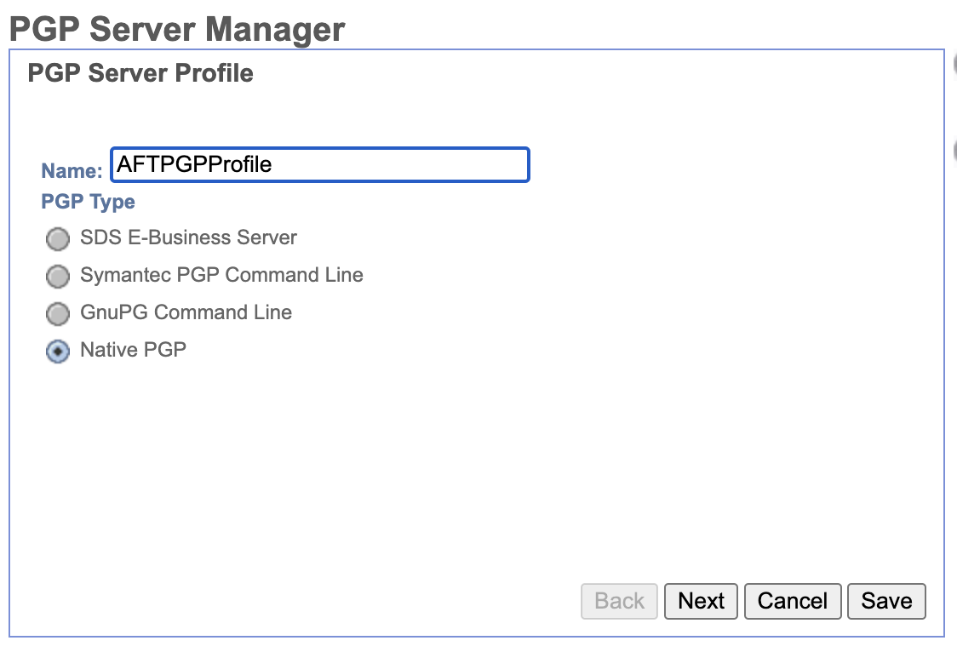
Select Native PGP to use built-in PGP in B2Bi.
Name AFTPGPProfile is required for SFG PGP layers.

Create Secret Key
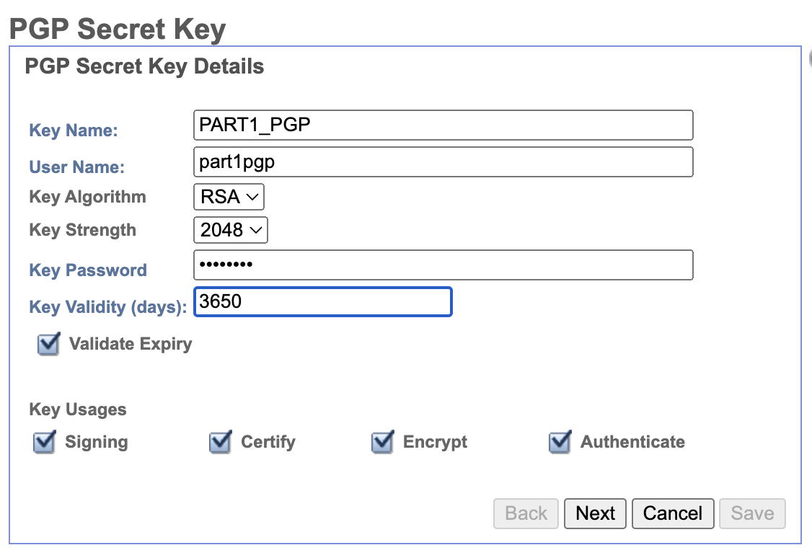
Password = passw0rd

Add Secret Key Map to PGP Server

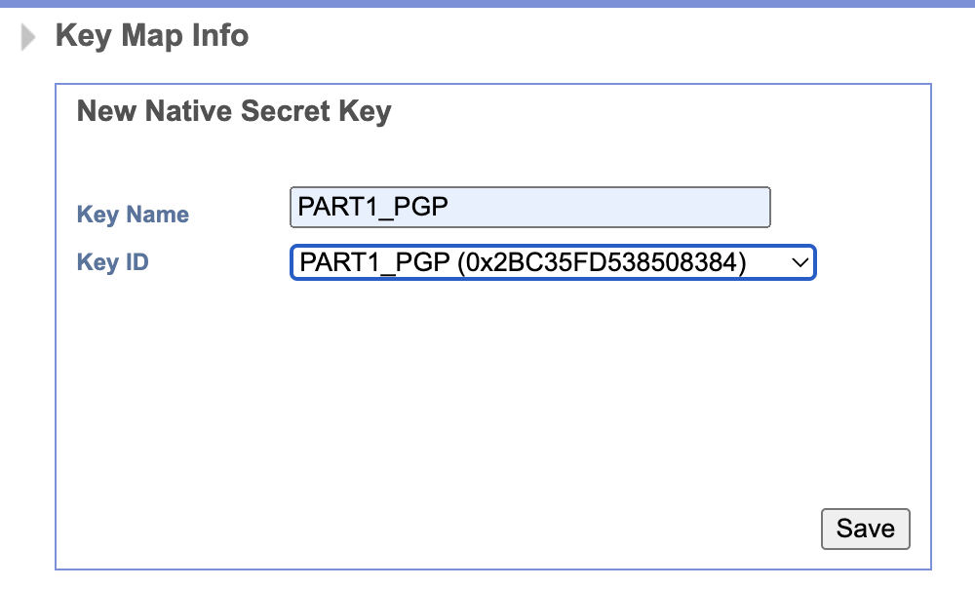

Export Public Key for import to GnuPG
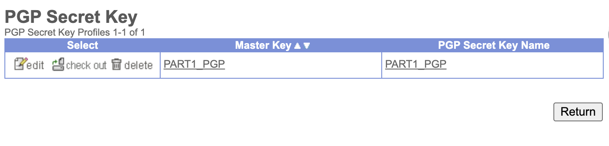
Finf your secret key then click on “check out”

Select 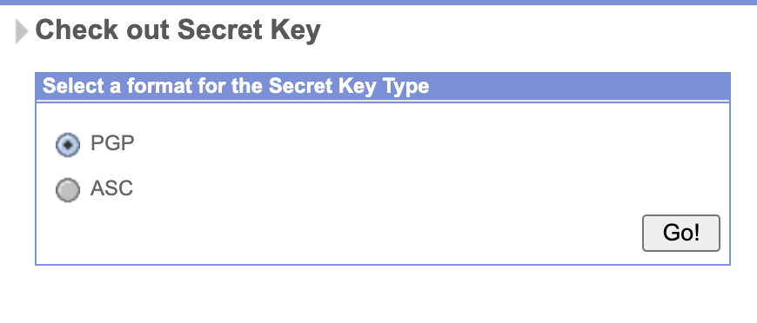Select PGP. File should be downloaded to your browser’s normal download folder. This file then needs to be imported to your GnuPG public key ring for use to encrypt files sent to SFG.

Import Public Key from GnuPG
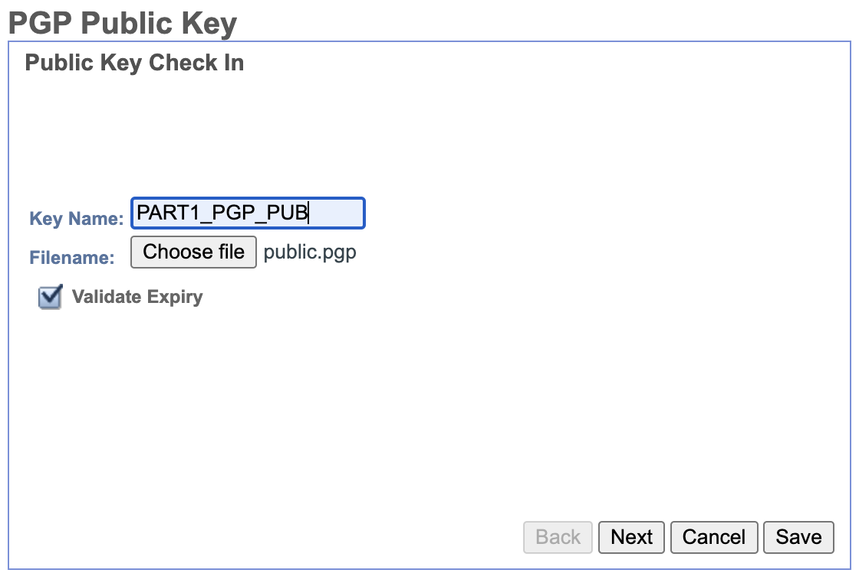
Select the public key you exported from GnuPG.
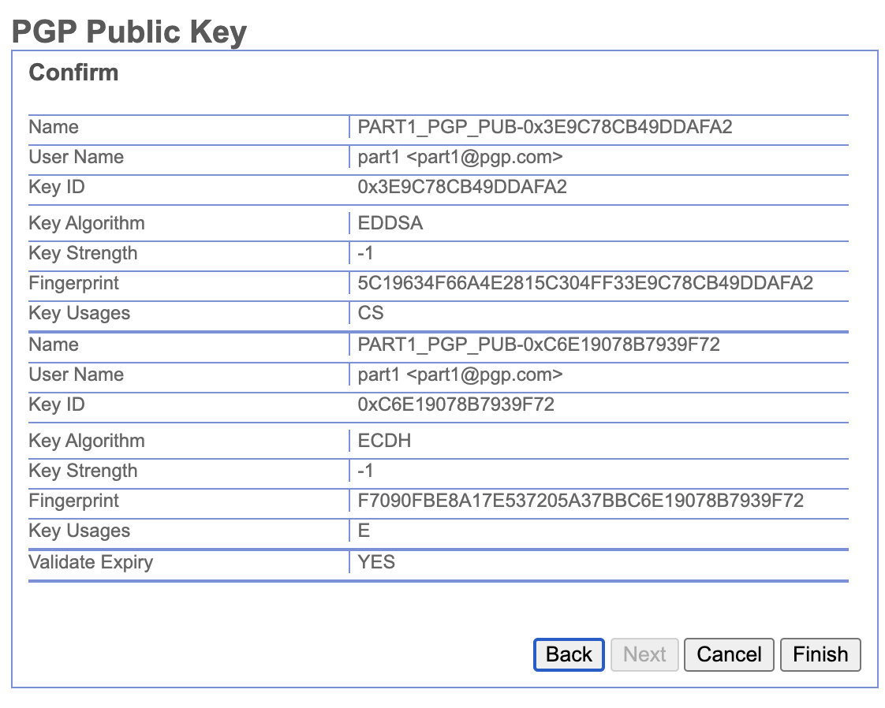

Create Community
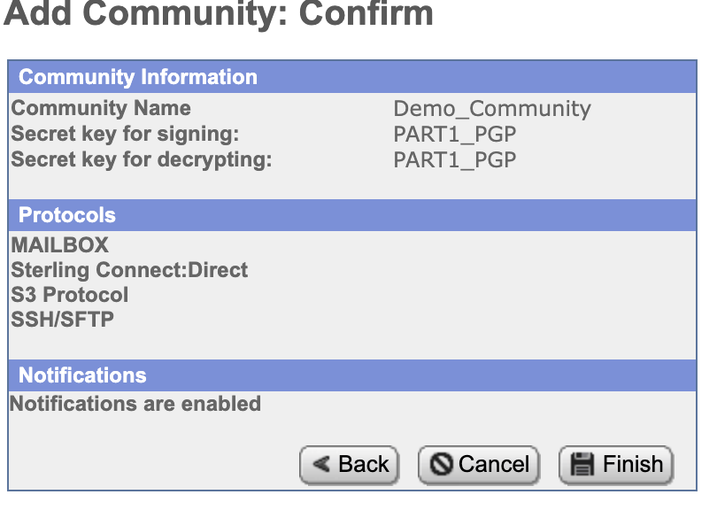
Select your secret key created earlier.

Create Partners
Partner2 will receive unencrypted files and route them to partner1, which requires them to be encrypted before delivery. Partner1 will receive encrypted files, decrypt, and then route back to partner2.

Partner1: PGP_PART1
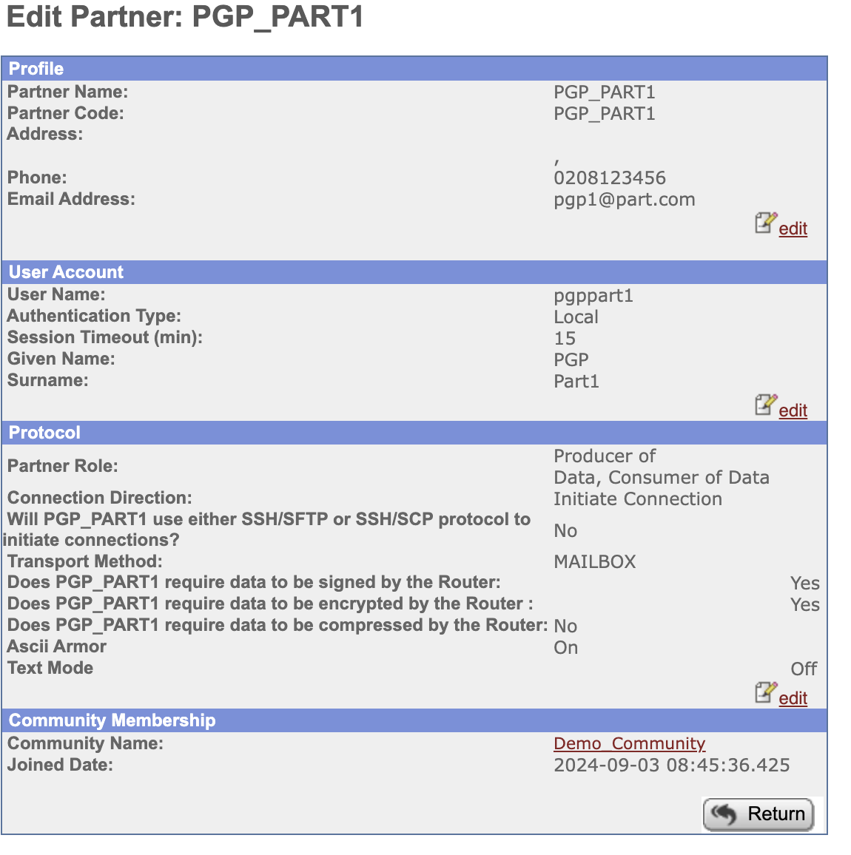
Partner1 expects PGP encrypted files.
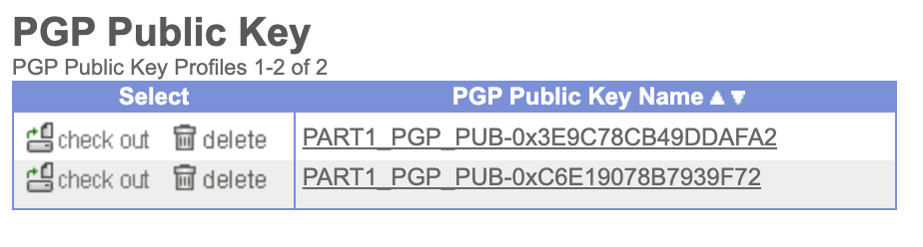
In B2B dashboard find your public keys exported from GnuPG.
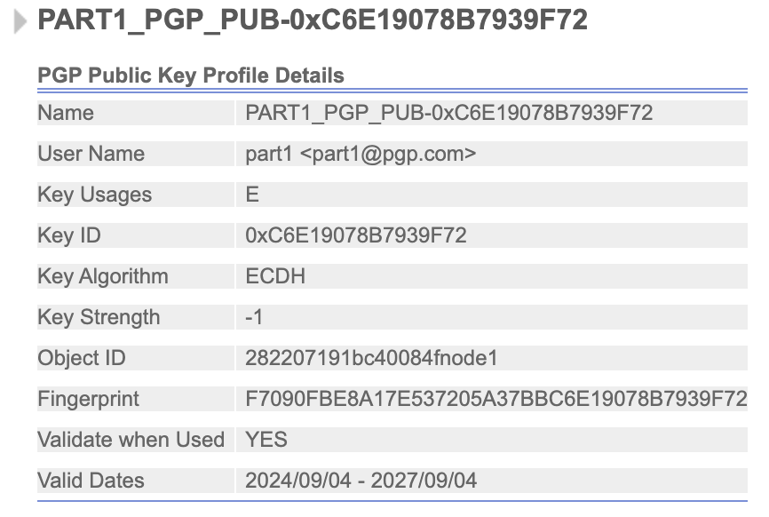
Make sure you pick the one with Key Usages=E and copy to clipboard the Key ID.

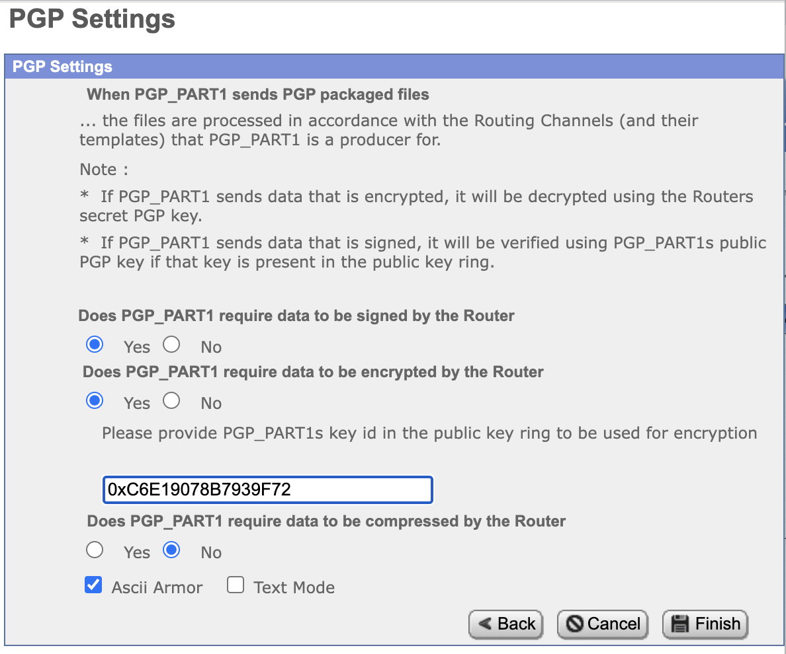
PGP Settings for partner1 pasting the key id of your imported public key. This is used to decrypt pgp files received from partner1.

Partner2: PART2_NOPGP
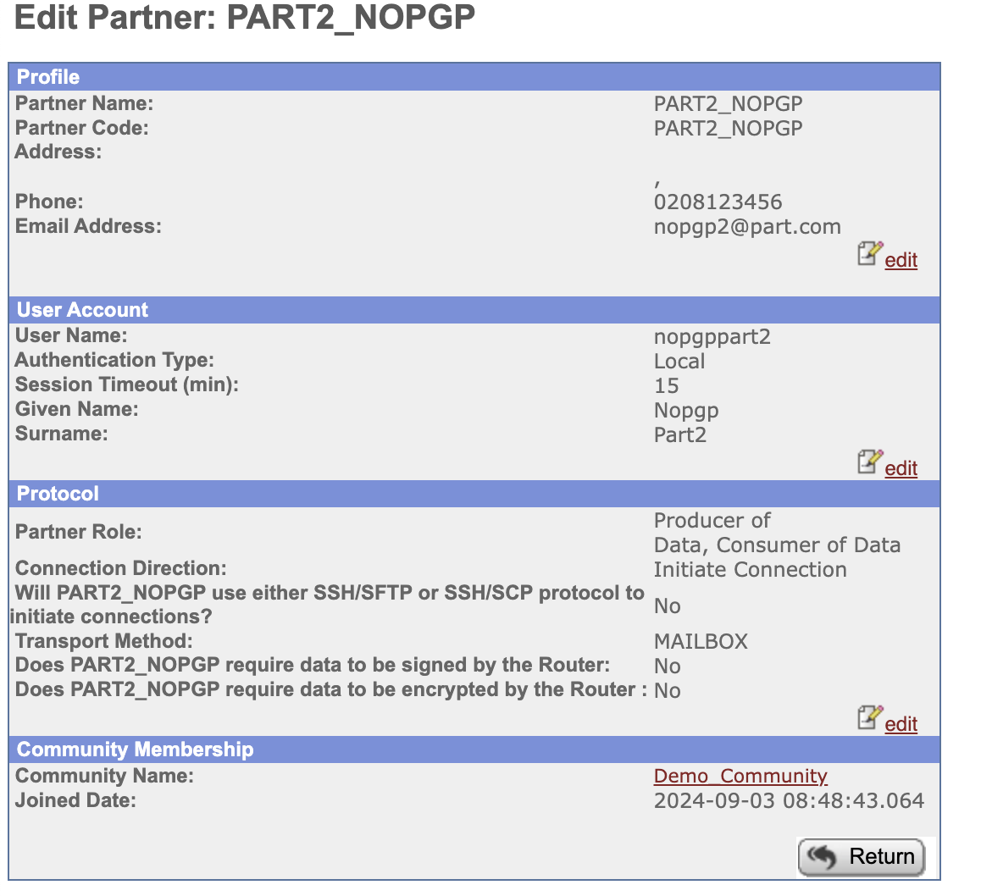
Partner2 does not require signing of files nor expects to receive PGP encrypted files.

Create Routing Channel Templates
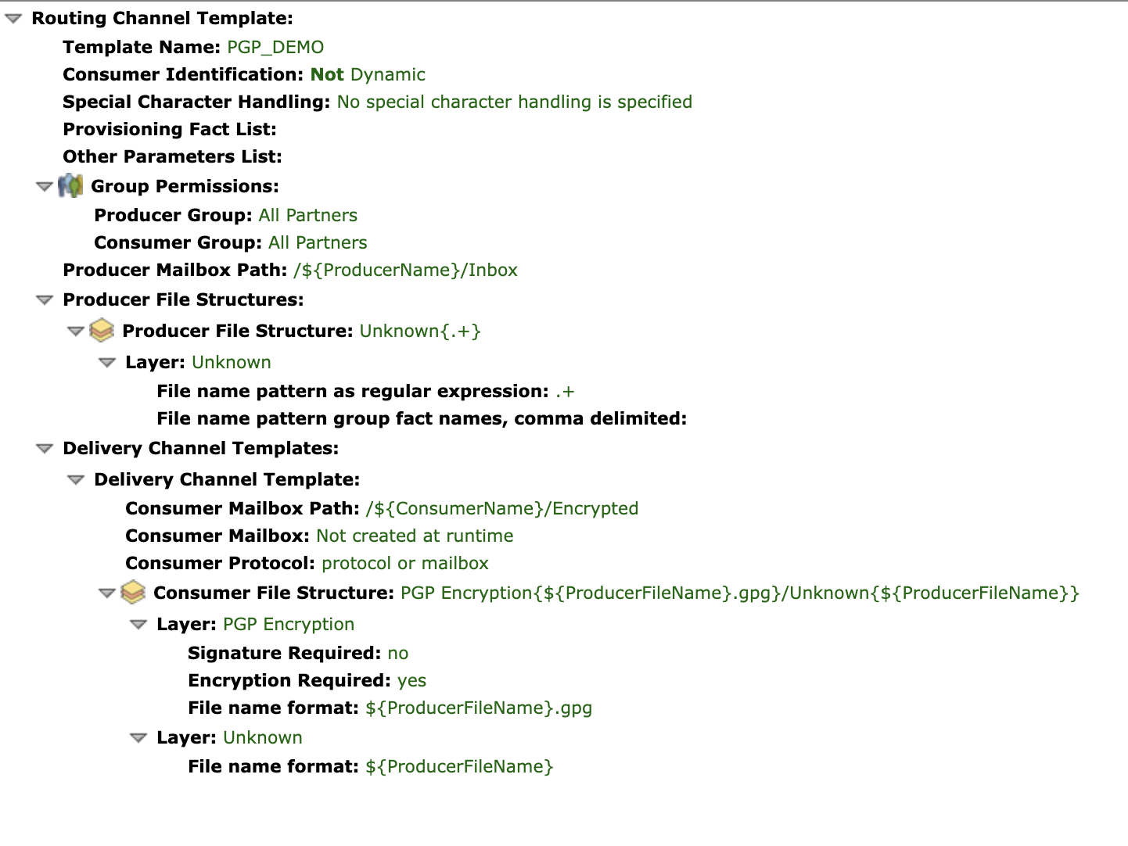
PGP template expects an unencrypted file which it will then encrypt as .gpg file before delivery using the public key of the consumer partner.
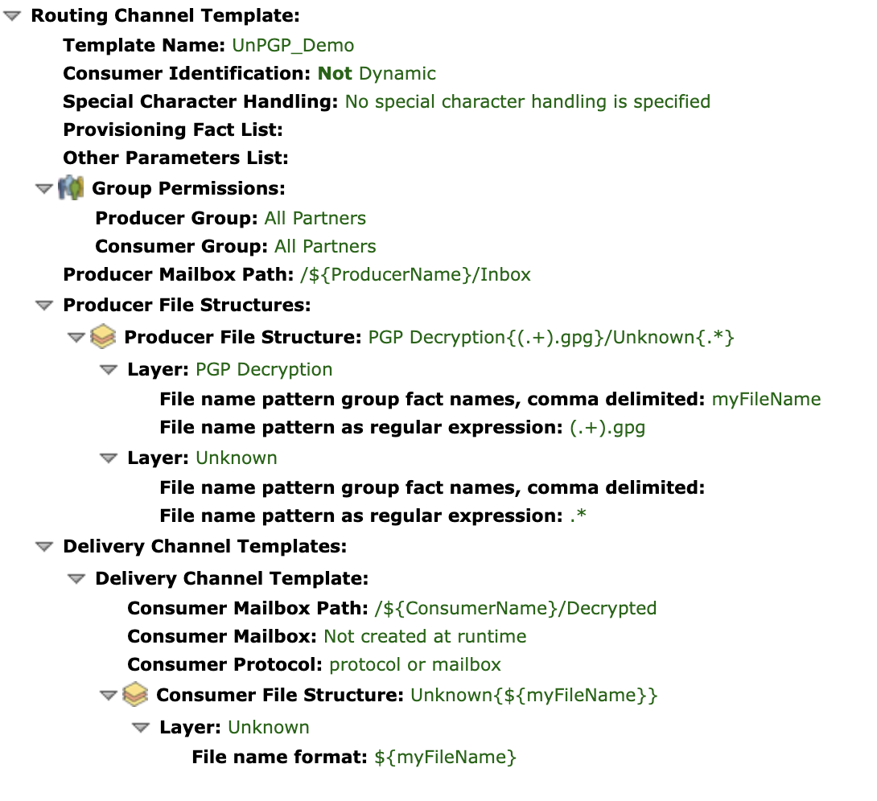
UnPGP template expects .gpg files to be received and will decrypt using community secret key then route to consumer unencrypted.

Create Routing Channels
Encrypt channel. Unencrypted file received by partner2 will be encrypted for delivery to partner1 using partner1’s public key.

Unencrypt channel. Encrypted file sent by partner1 to partner2 will be unencrypted using community secret key.

Demo

Outbound Route
Upload unencrypted test file pgp_demo.txt as partner2 to /Inbox using myFileGateway (or protocol of your choice).
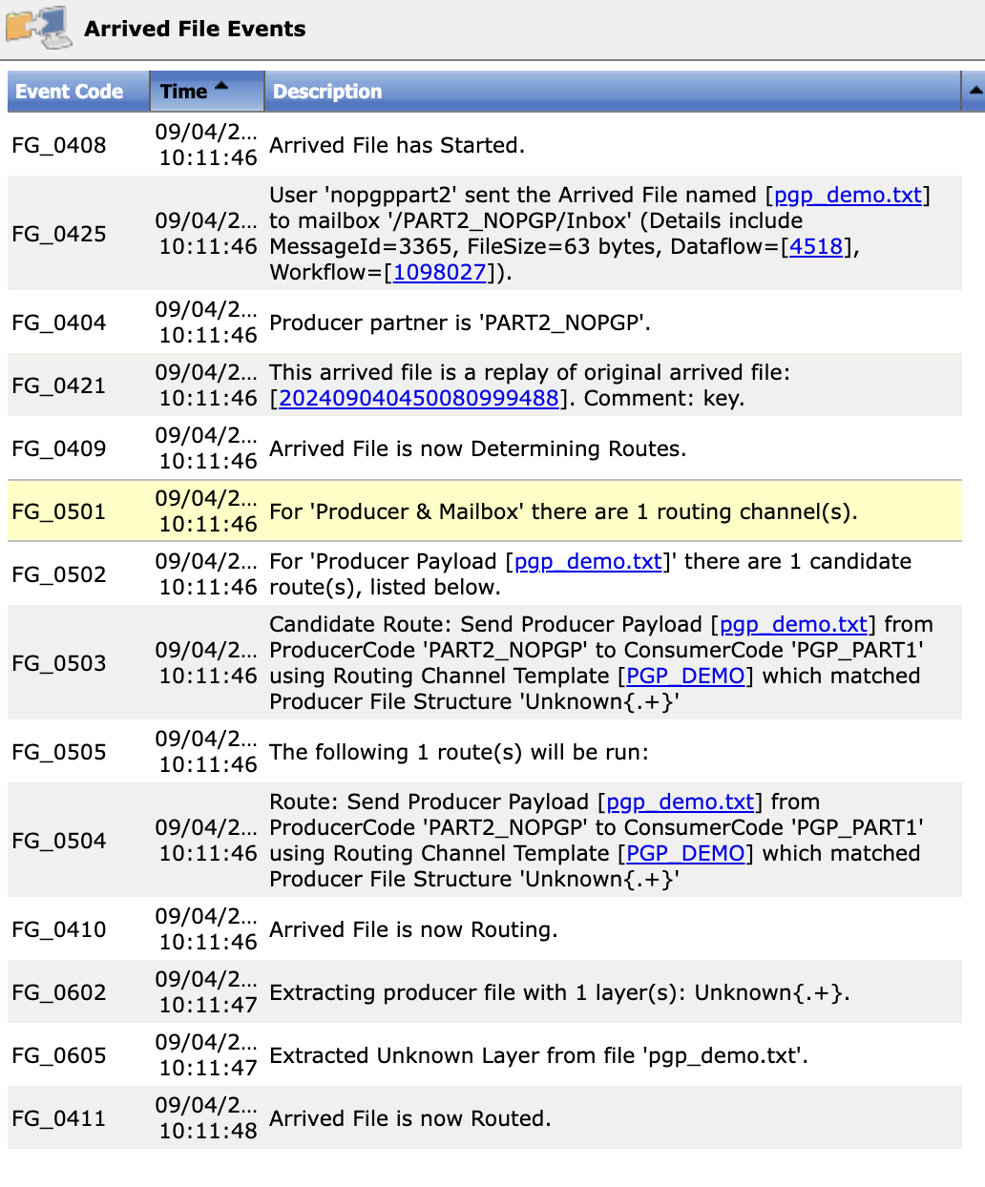
Unencrypted file is received and routed.
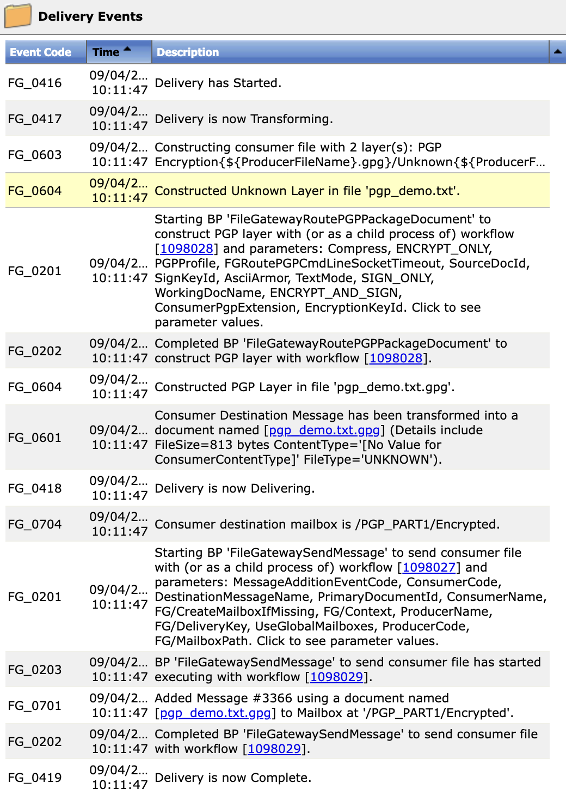
File is encrypted before delivery.
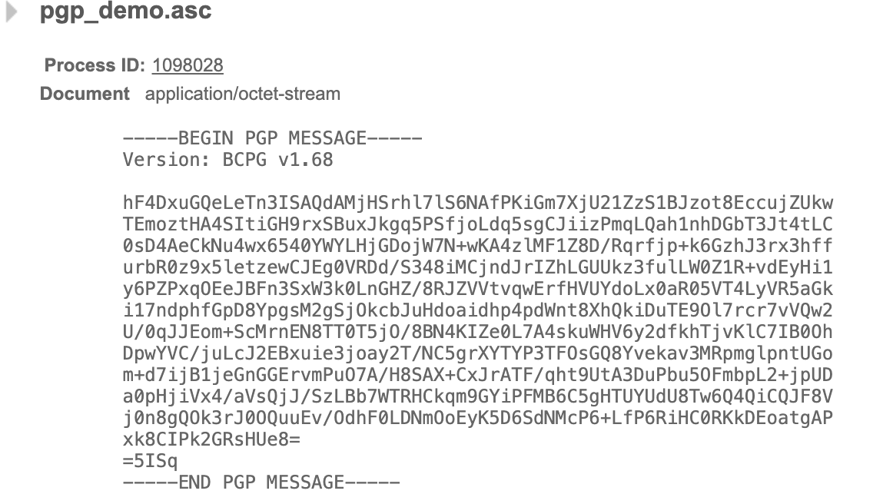
File is encrypted.

Inbound Route
Upload file encrypted using GnuPG to Partner1’s Inbox using myFileGateway (or protocol of your choice).
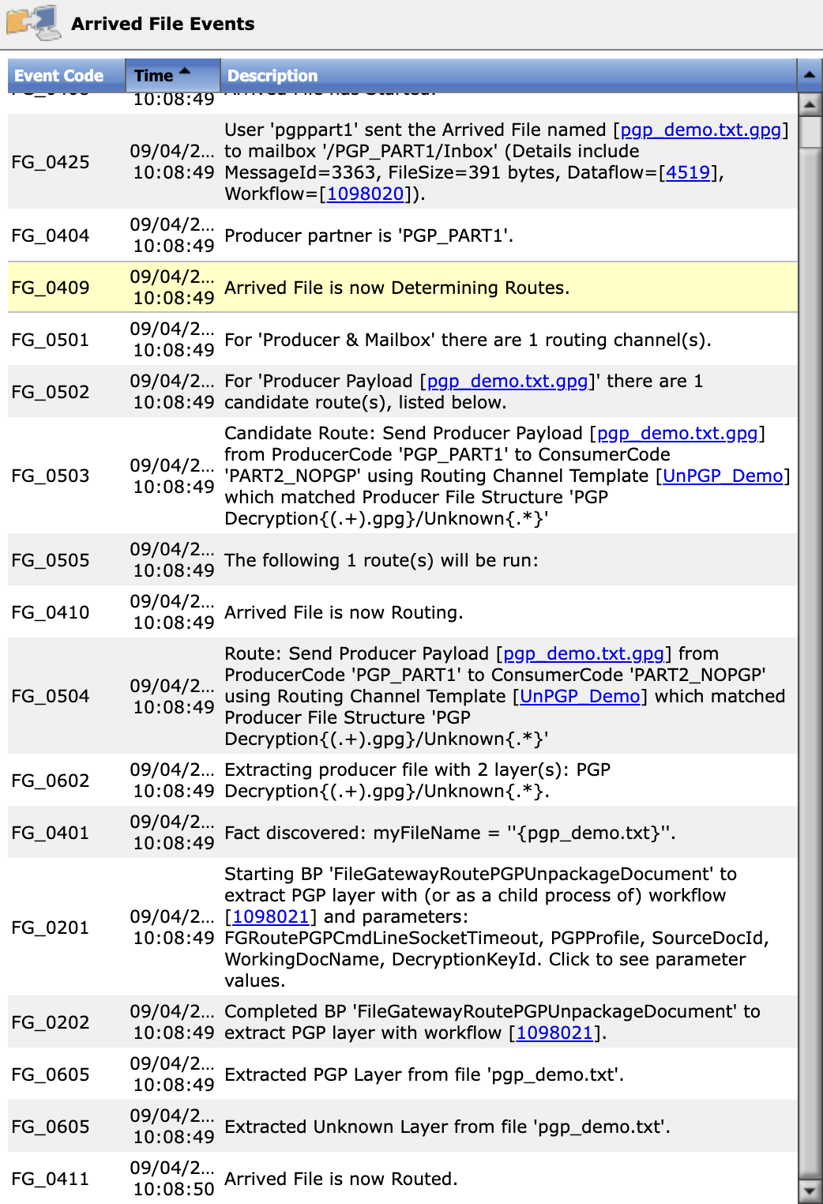
PGP file is decrypted on receipt.
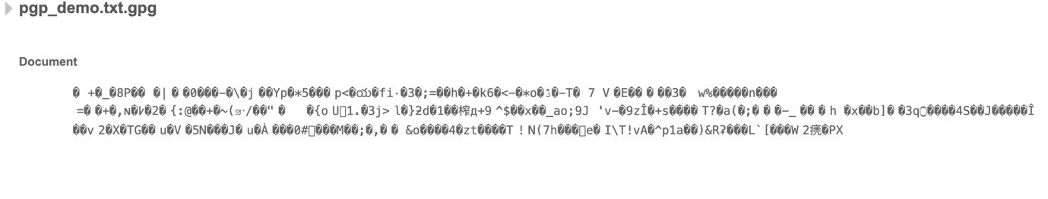
GnuPG encrypted file.

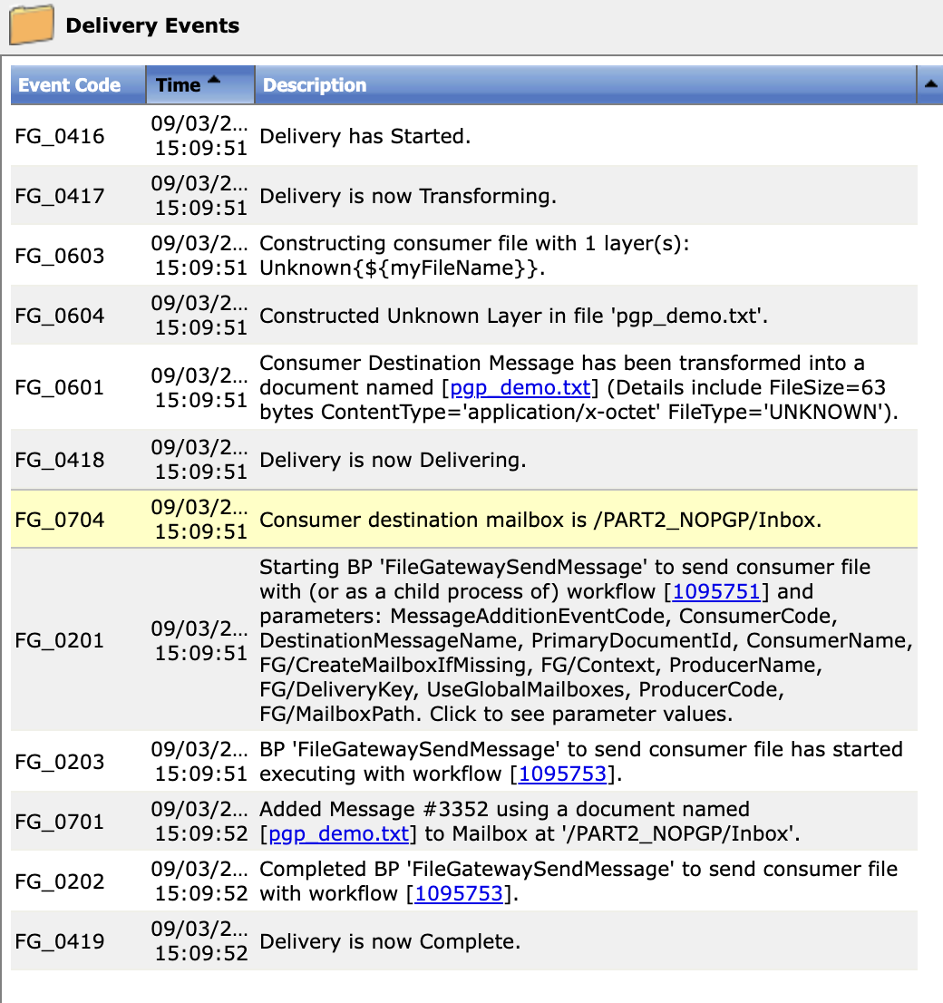
Decrypted file delivered to consumer mailbox.

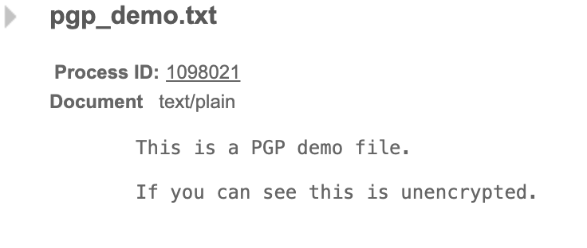
File has been decrypted.

